**Project- Mix And Match Deal**

Environment- Prod

**Bug Report-**

1. There is no validation for the maximum character limit on the title, subtitle, CTA text, and bundle name text, and the design is broken for these reasons.

**Priority-** High

**Severity**- Major

Status- Open

Assigned By- Imran

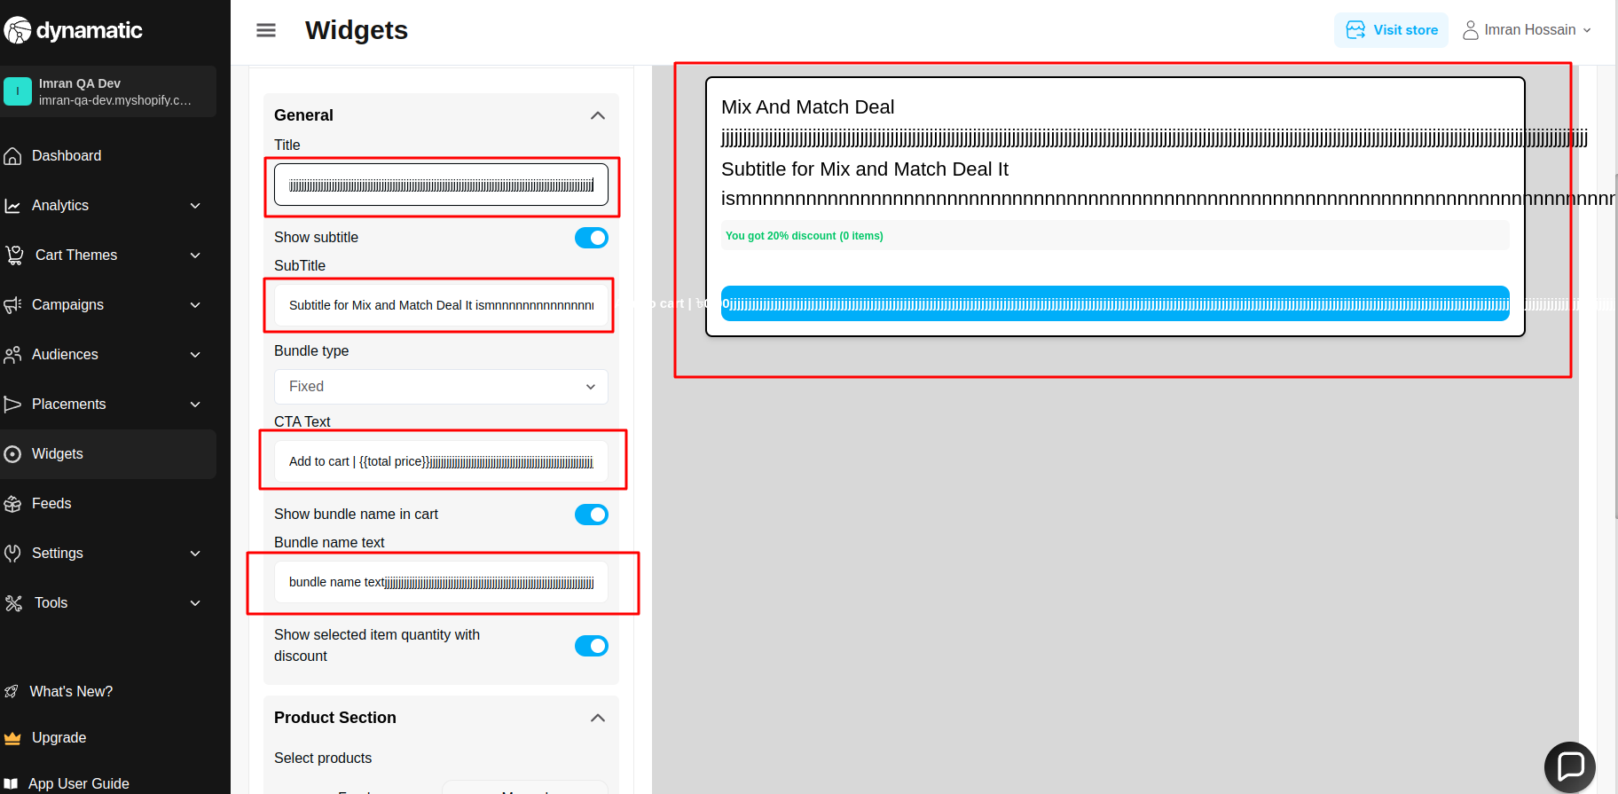

2. Product section => When I add a product from the feeds, it saves correctly. However, when I click the manual option, the saved feed product disappears.

**Priority-** High

**Severity**- Major

Status- Open

Assigned By- Imran

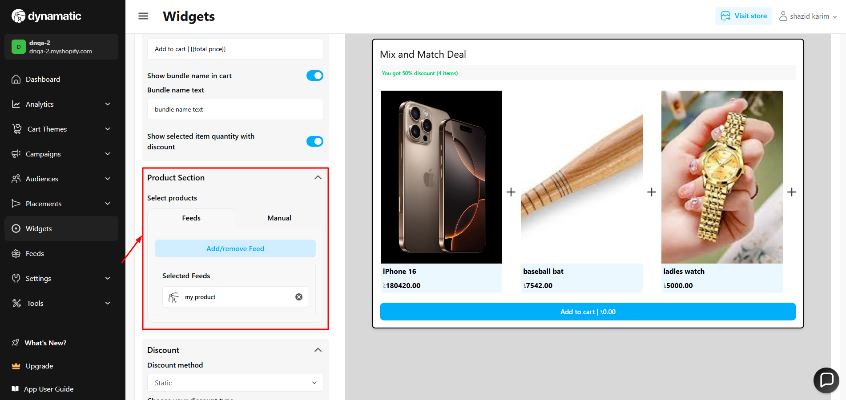

**3. Product section => add/remove feed => When I add a product from the feed, I search for my feed name, select one feed, and click "Add Selected Feed" — it works as expected. However, when I try to add another product from the feed, all the other feeds disappear, and only the previously selected feed remains.(this issue is faced in all server)**

**Priority-** High

**Severity**- Major

Status- Open

Assigned By- Imran

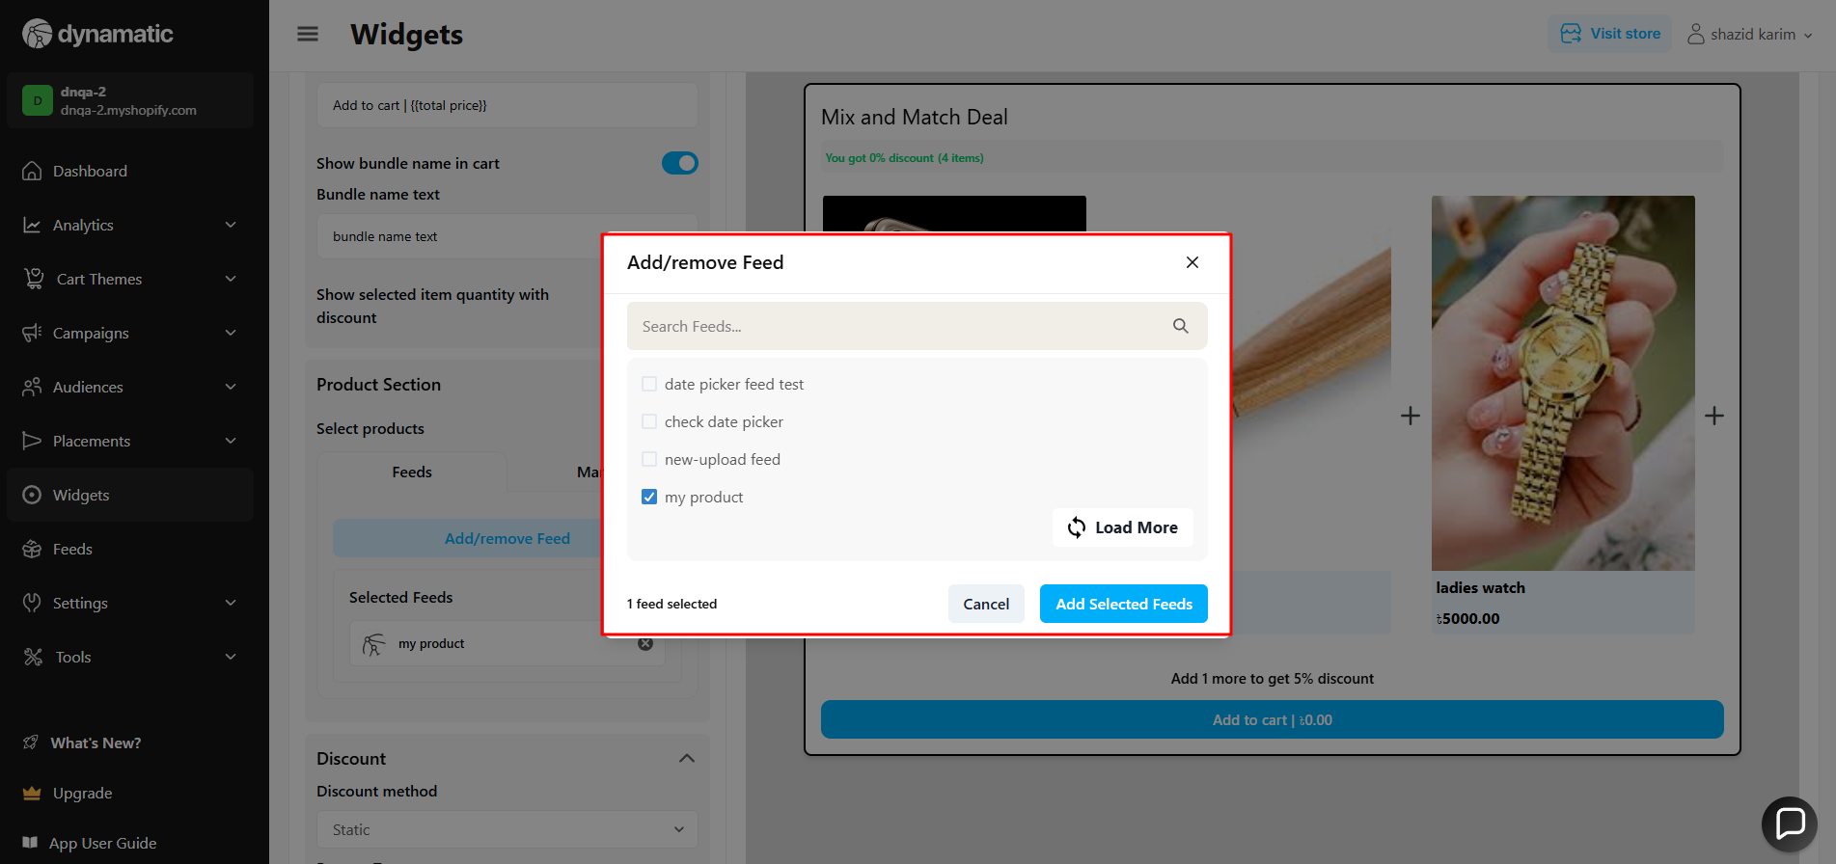

After selecting one feed this is the all feed section=>

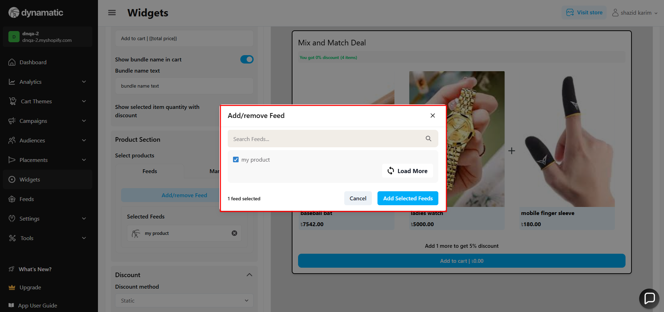

**4. Product section => add/remove feed => Load more button does not work(this issue is faced in all server).**

**Priority-** High

**Severity**- Major

Status- Open

Assigned By- Imran

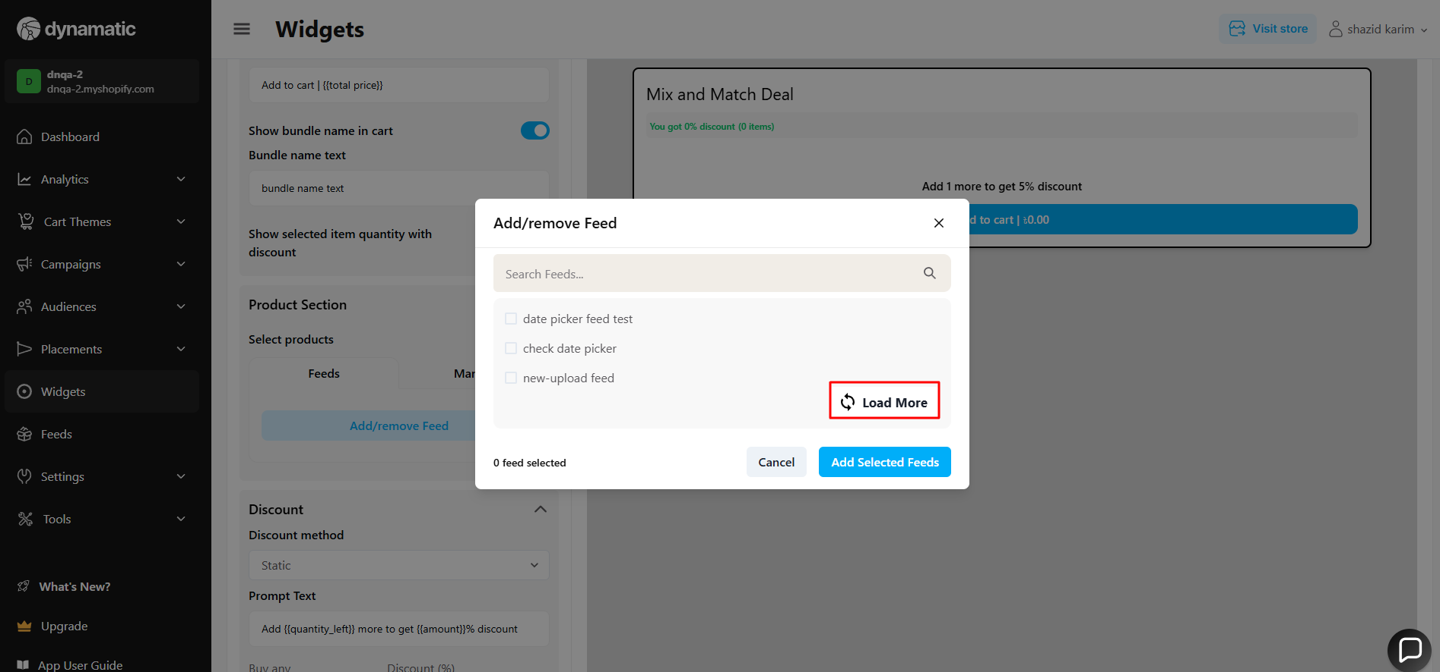

5.When bundle type dynamic, at this time change bundle type to fixed, and then discount preview is not gone.

**Priority-** High

**Severity**- Major

Status- Open

Assigned By- Imran

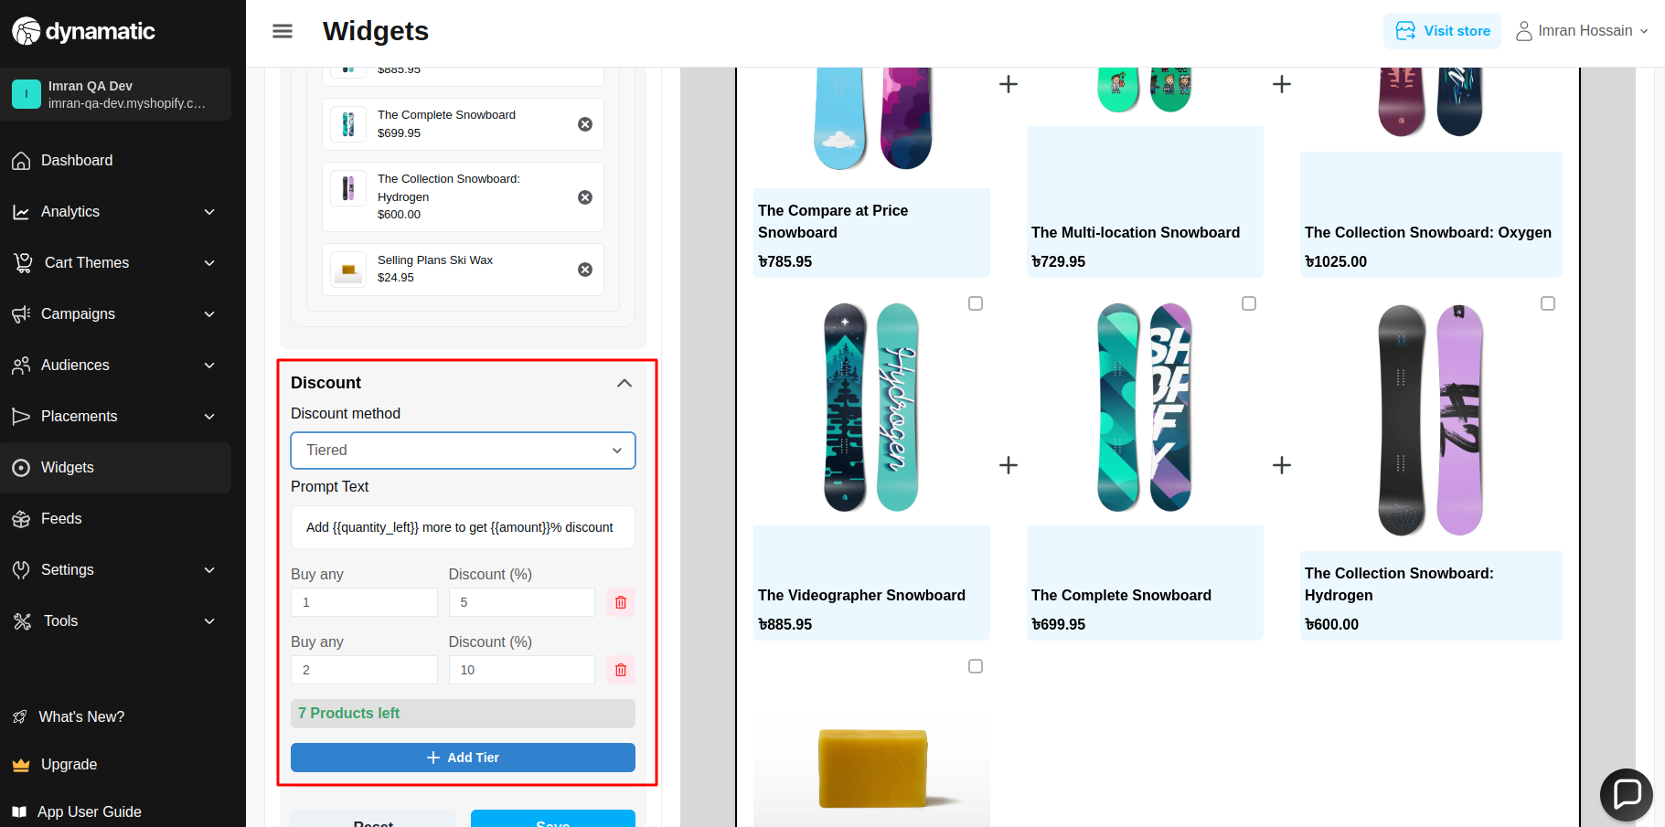

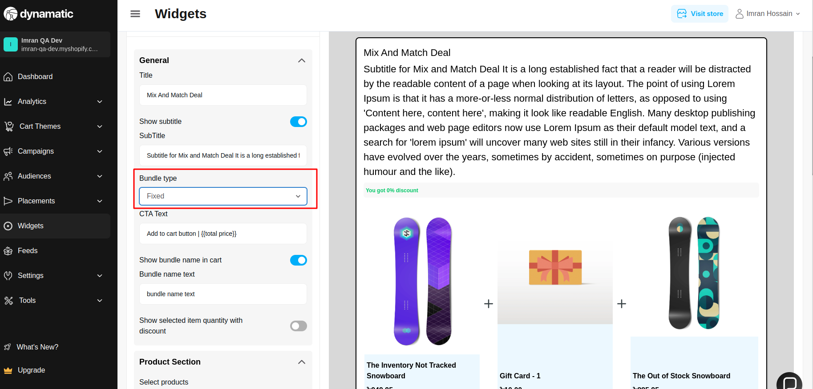

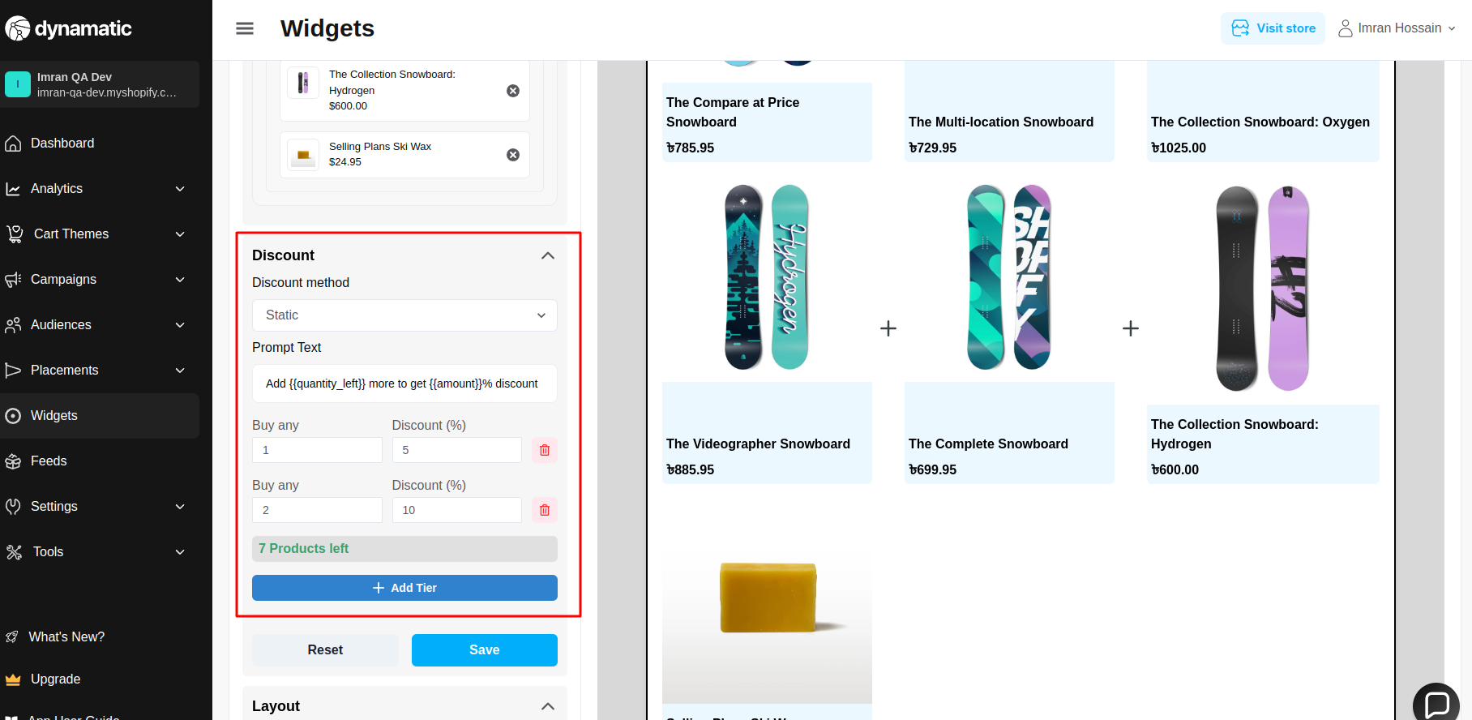

6. Discount method calculation does not work properly.

**Priority-** High

**Severity**- Major

Status- Open

Assigned By- Imran

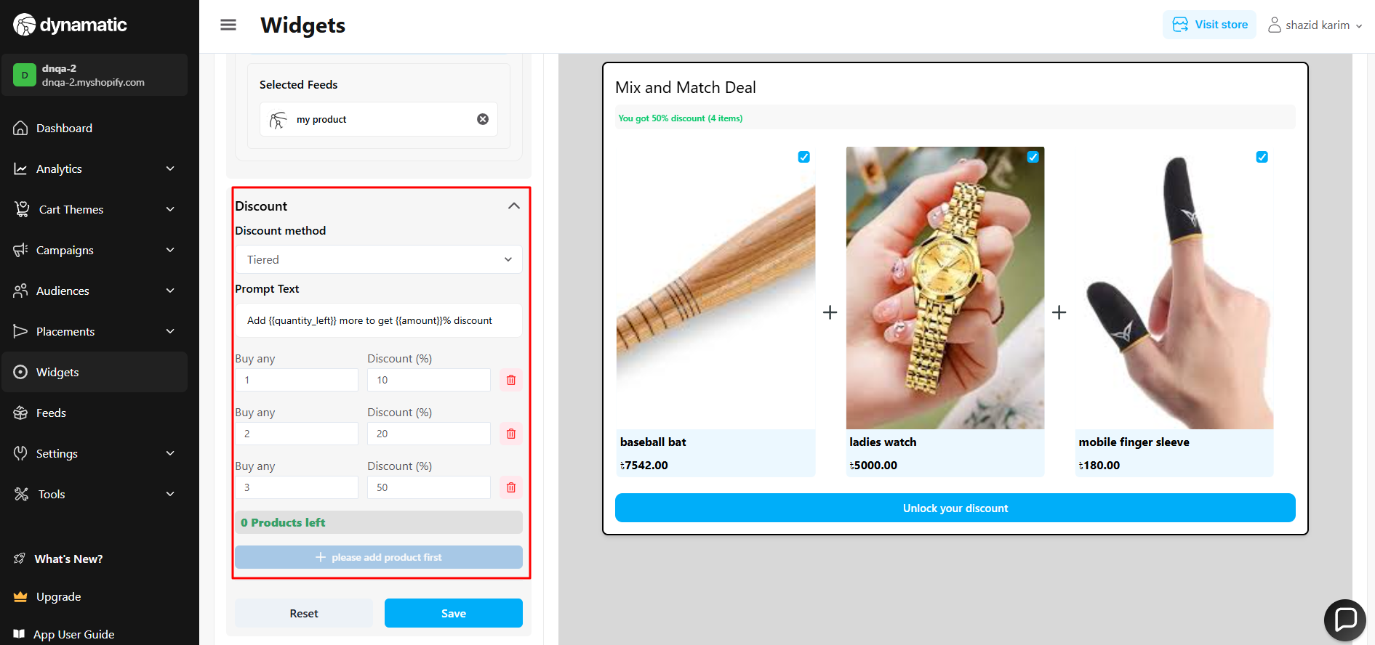

7. Discount method tier list needs validation. It takes multiple tiers for the product item.

**Priority-** High

**Severity**- Major

Status- Open

Assigned By- Imran

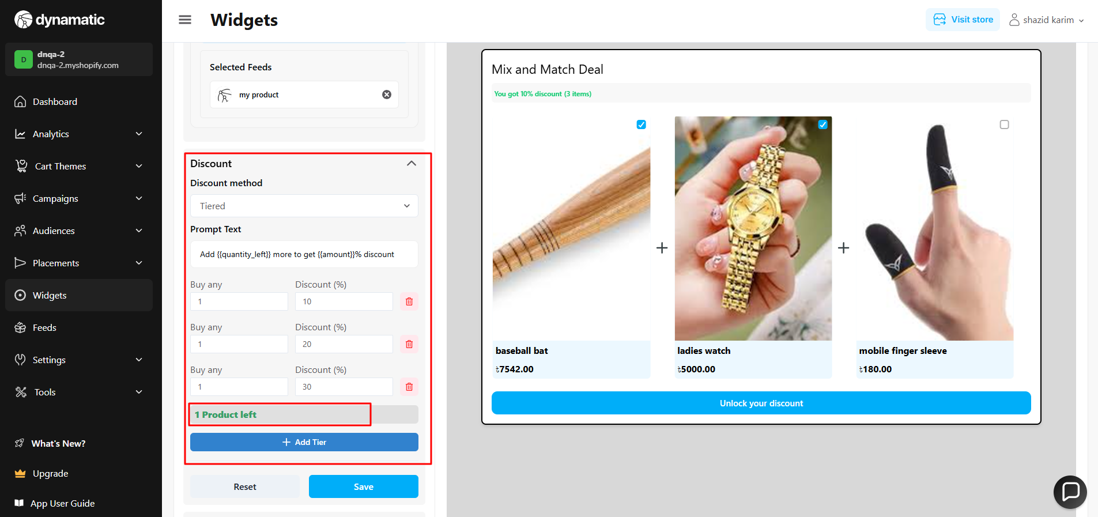

8. Discount method percentages need validation. It takes 0 and negative values.

**Priority-** High

**Severity**- Major

Status- Open

Assigned By- Imran

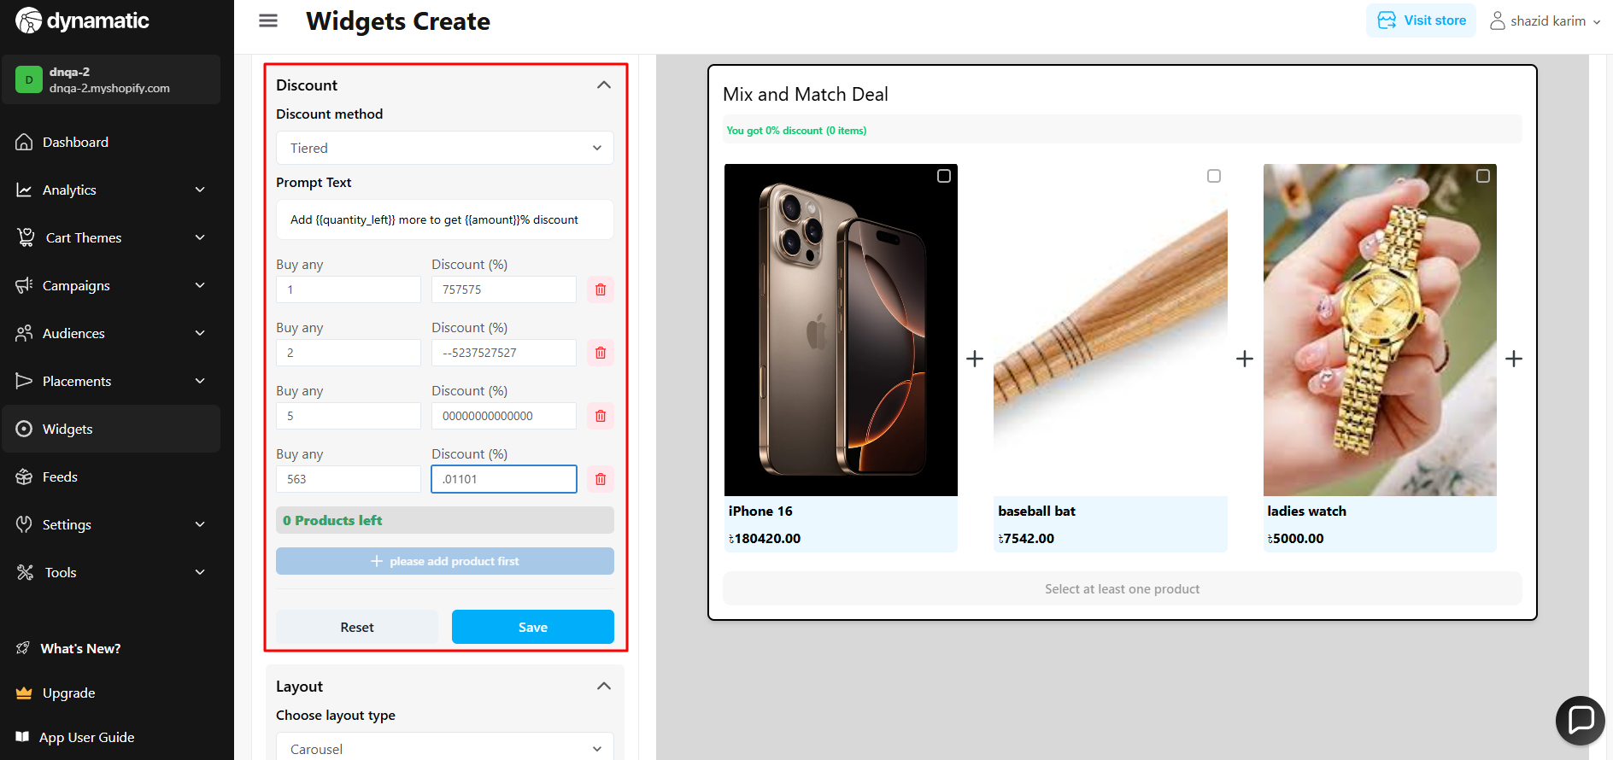

9. Discount method=> product specific => When I add a discount to a single product, it works correctly. In the preview, when I select the discounted product, the discount amount is applied properly. However, when I select a different product, the discount percentage gets split among the selected items.

**Priority-** High

**Severity**- Medium

Status- Open

Assigned By- Imran

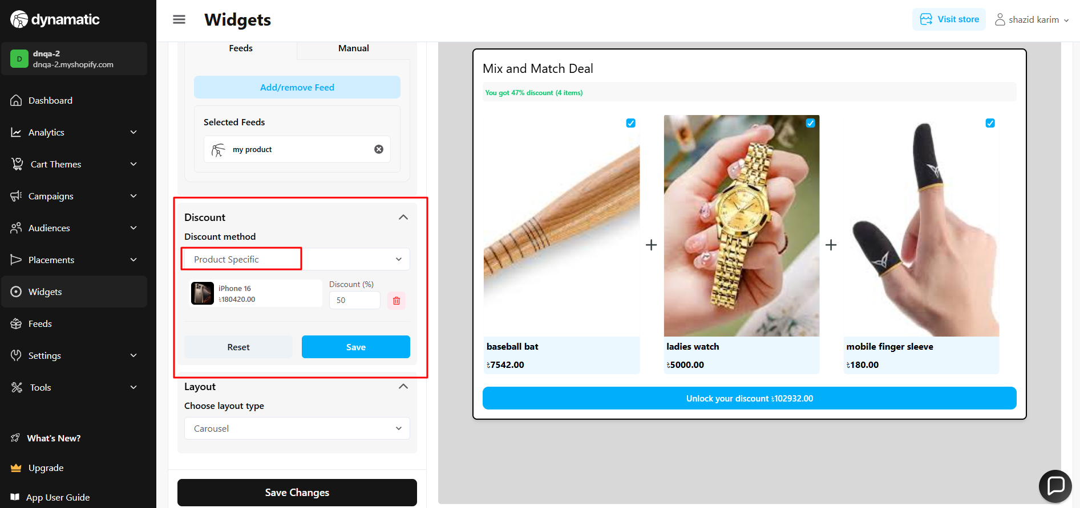

10. Dis count method => product specific => There's an issue with the reset button functionality. When I click the reset button, all the products disappear. It’s supposed to only remove the discount percentages.

**Priority-** High

**Severity**- Medium

Status- Open

Assigned By- Imran

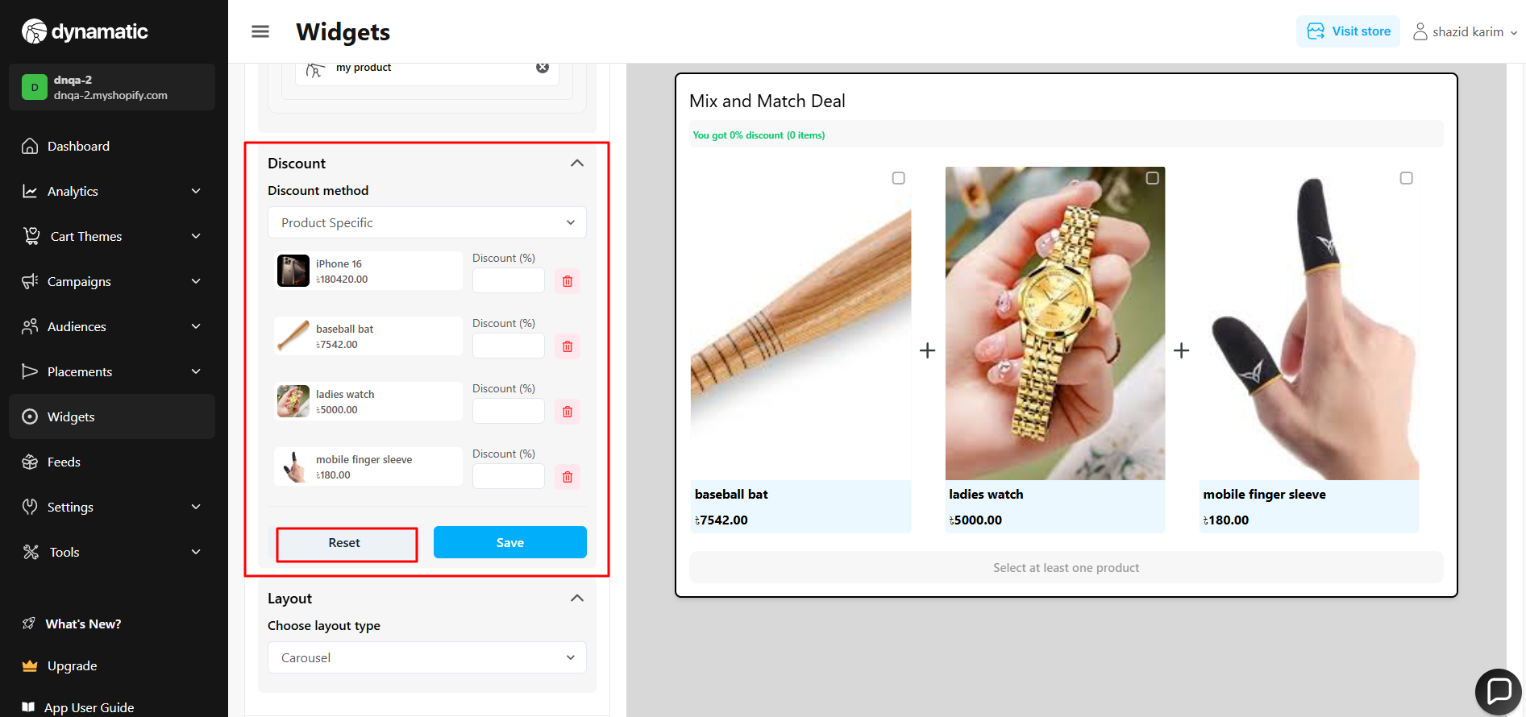

11. Discount method => product specific => When I add a discount to a single product and click save, the discount is applied correctly, but the percentage does not appear in the discount field.

**Priority-** High

**Severity**- Medium

Status- Open

Assigned By- Imran

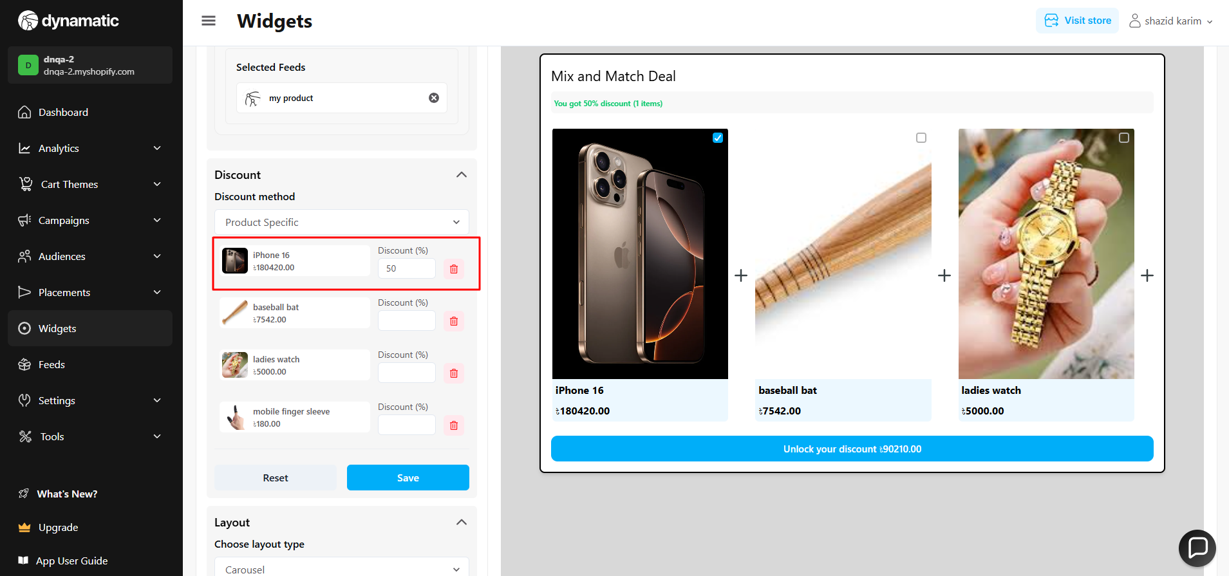

12. Discount method => product specific => multiple different discounts does not work properly for multiple products.

**Severity**- Medium

Status- Open

Assigned By- Imran

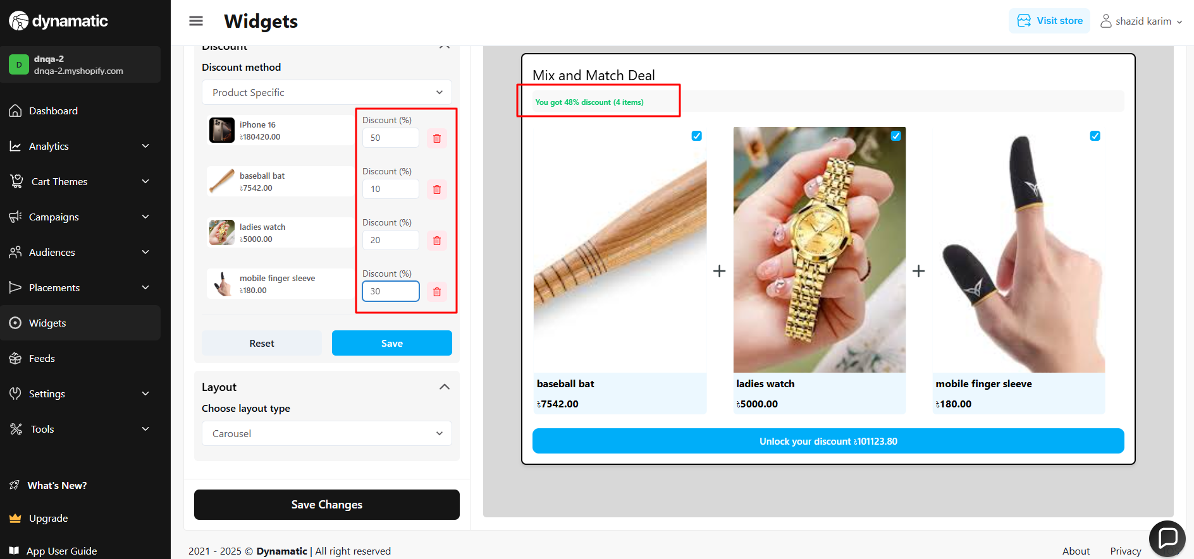

**Style and advanced**

1. Add validation on Max width (PX).

**Priority-** High

**Severity**- Medium

Status- Open

Assigned By- Imran

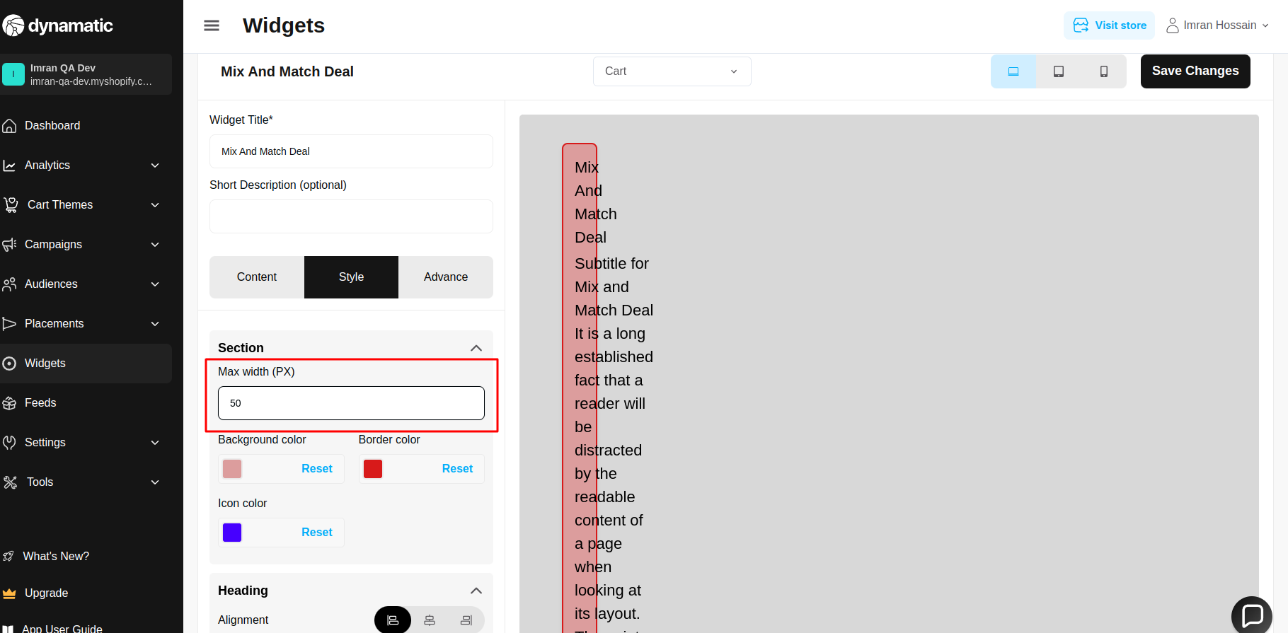

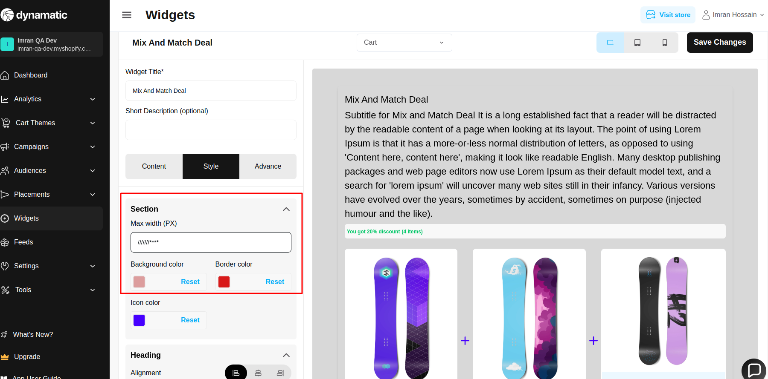

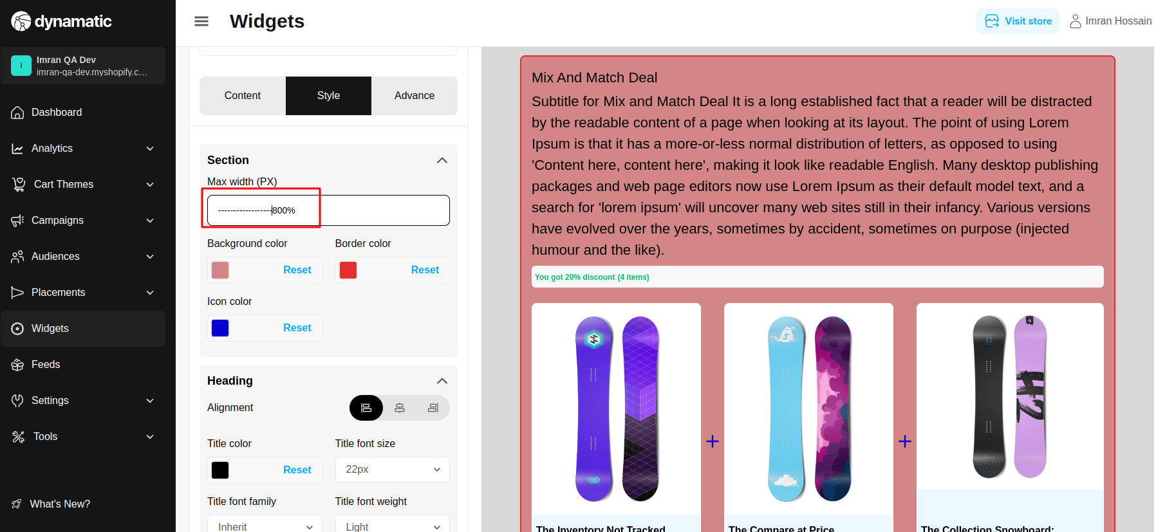

2. Heading Title font family is not working.

**Priority-** Medium

**Severity**- Medium

Status- Open

Assigned By- Imran

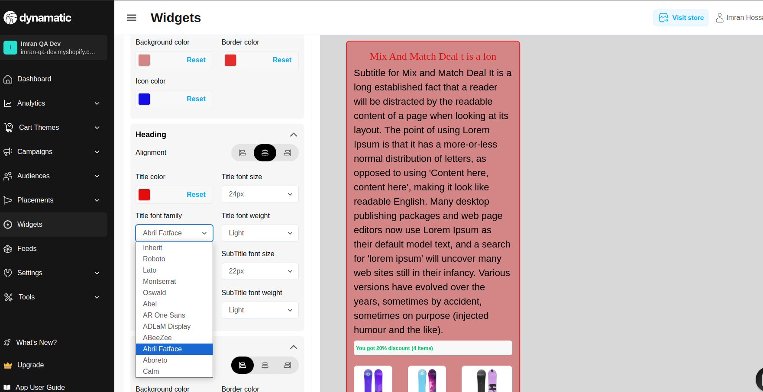

3. Click on heading Title color and also click on Title font weight at this time; 2 modals are opened.

**Priority-** Medium

**Severity**- Medium

Status- Open

Assigned By- Imran

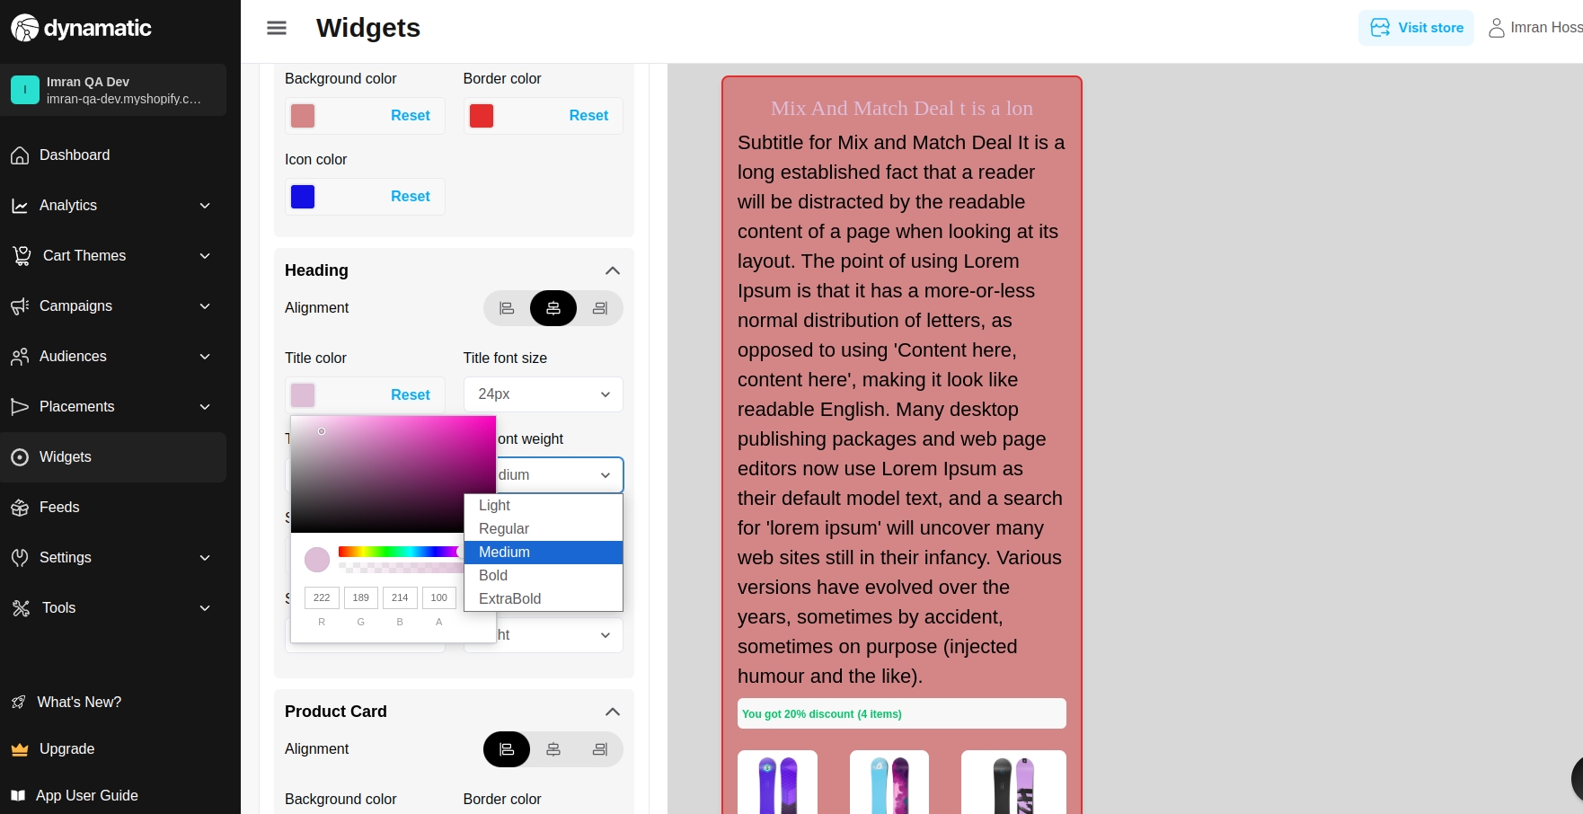

4. Heading title font weight (Light,Regular, Medium) is not properly showing.

**Priority-** High

**Severity**- Medium

Status- Open

Assigned By- Imran

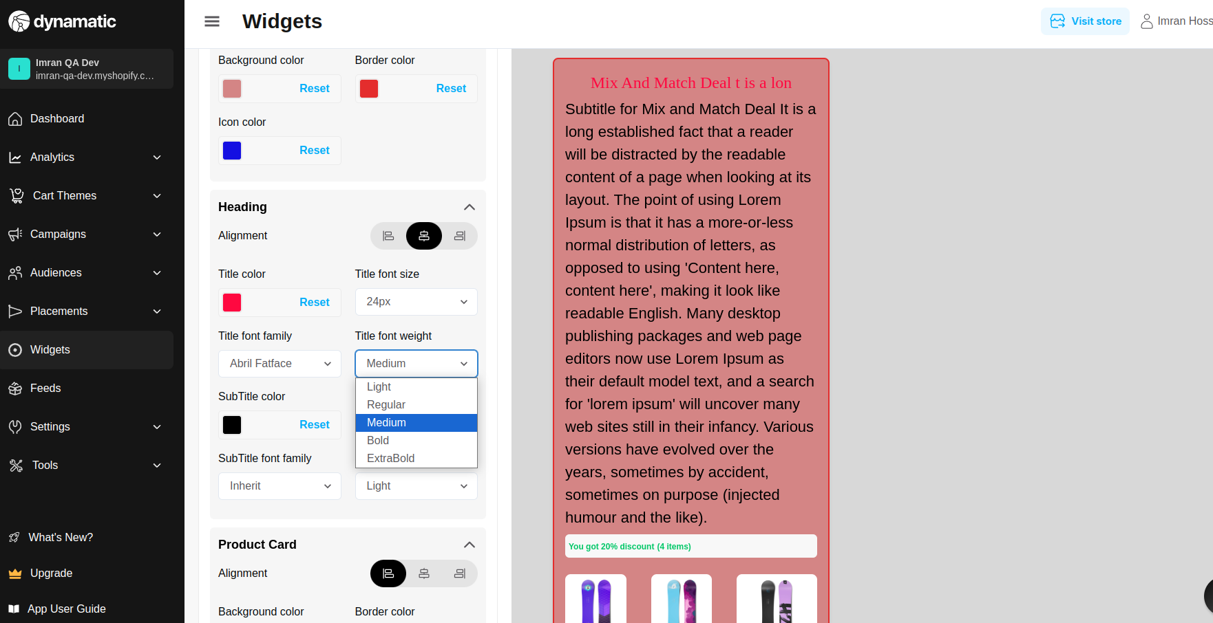

5.Heading SubTitle font family (AR One Sans,ADLaM Display,AbeeZee,Abril Fatface,Aboreto,Calm) is not properly working.

**Priority-** High

**Severity**- Medium

Status- Open

Assigned By- Imran

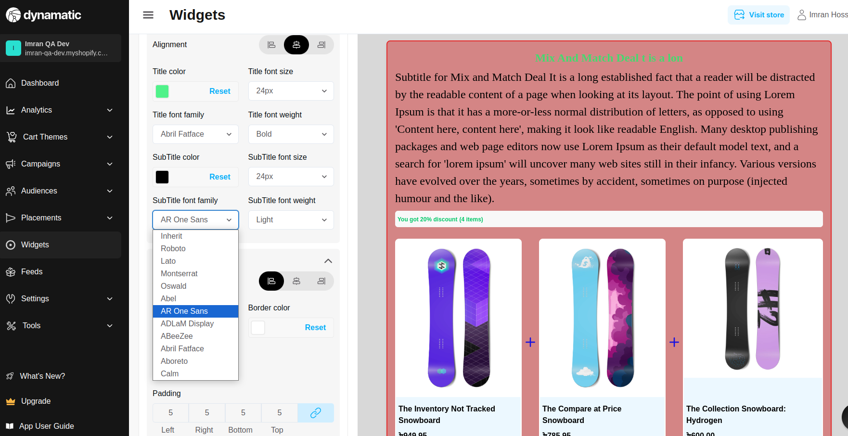

6.Heading SubTitle font weight only working bold but other font is not working.

**Priority-** High

**Severity**- Major

Status- Open

Assigned By- Imran

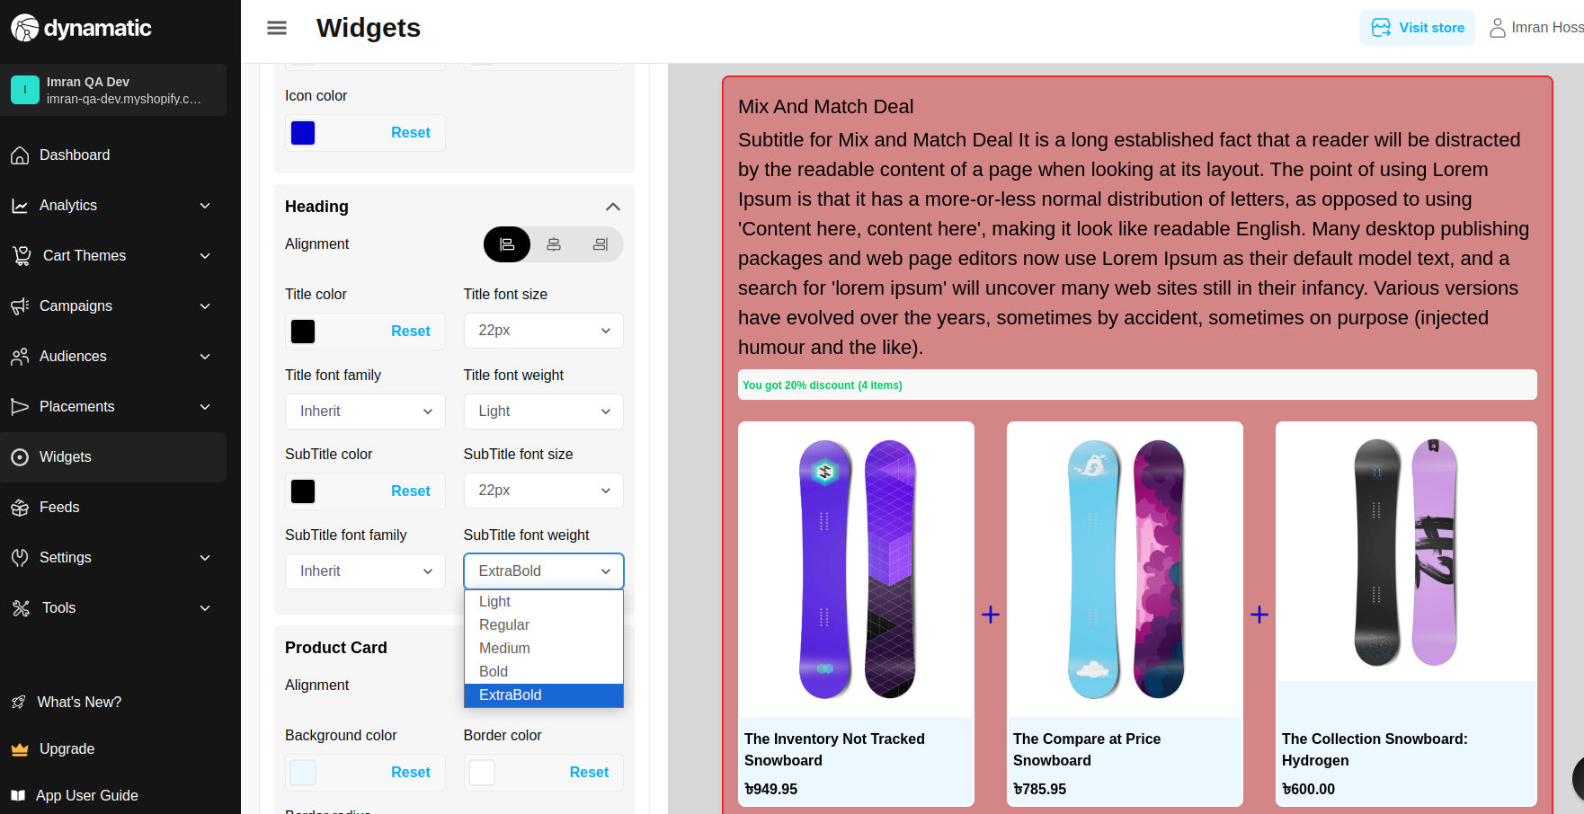

7.When border radius is 50% at this time, the product title preview is not properly showing.

**Priority-** Medium

**Severity**- Medium

Status- Open

Assigned By- Imran

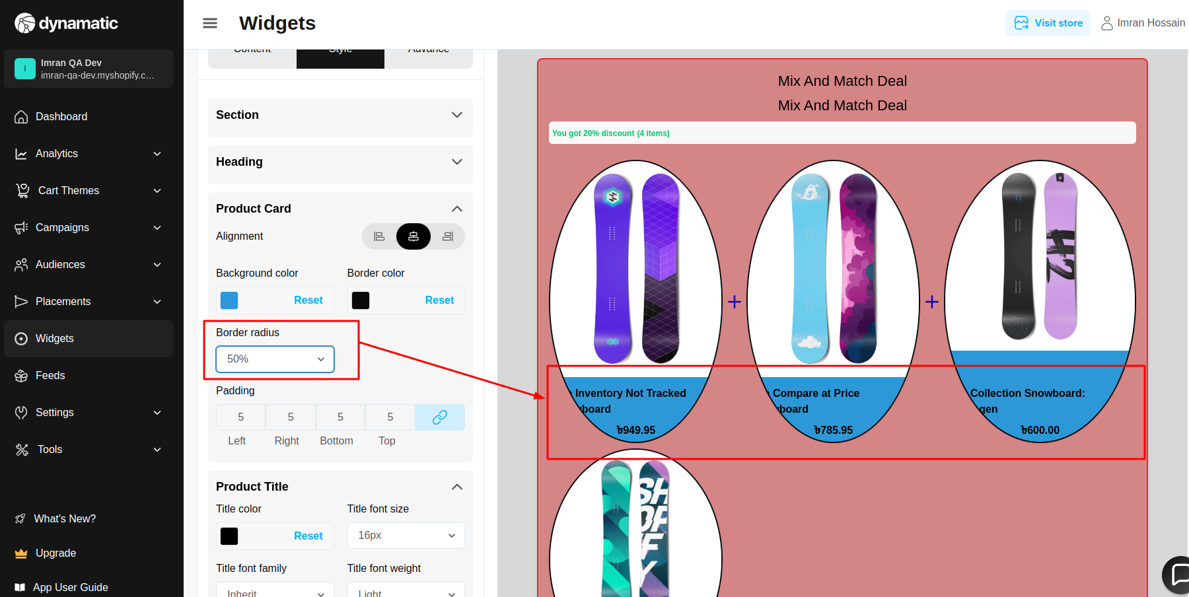

8. Negative value is added; add validation on padding.

**Priority-** Medium

**Severity**- Medium

Status- Open

Assigned By- Imran

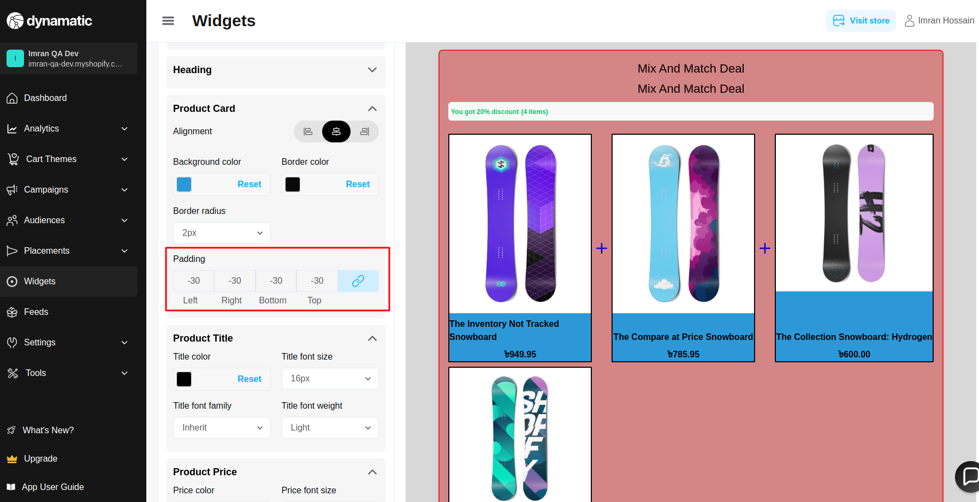

9. Product Title font family (AR One Sans,ADLaM Display,AbeeZee,Abril Fatface,Aboreto,Calm) is not properly working.

**Priority-** High

**Severity**- Medium

Status- Open

Assigned By- Imran

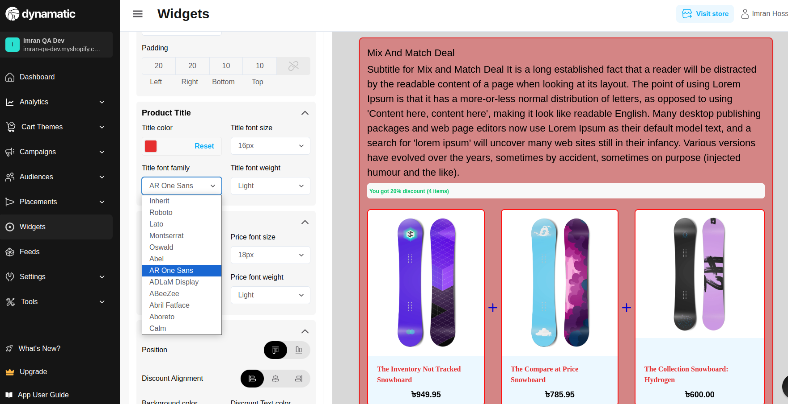

10. Product Title Title font weight only working with bold font weight, but other fonts are not working.

**Priority-** High

**Severity**- Medium

Status- Open

Assigned By- Imran

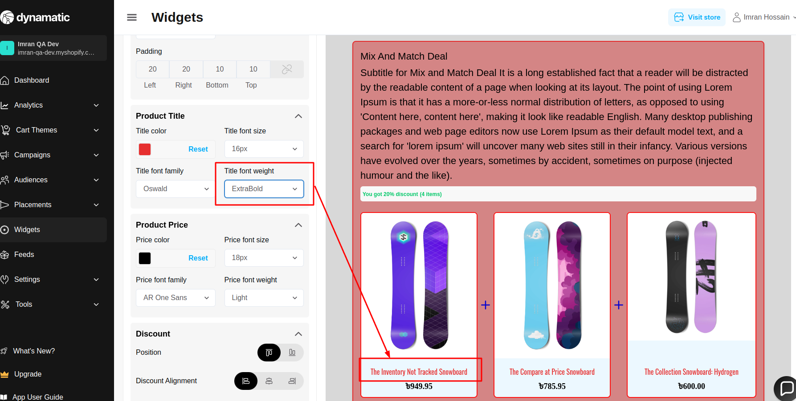

11.Product Price font family (AR One Sans,ADLaM Display,AbeeZee,Abril Fatface,Aboreto,Calm) is not properly working.

**Priority-** High

**Severity**- Medium

Status- Open

Assigned By- Imran

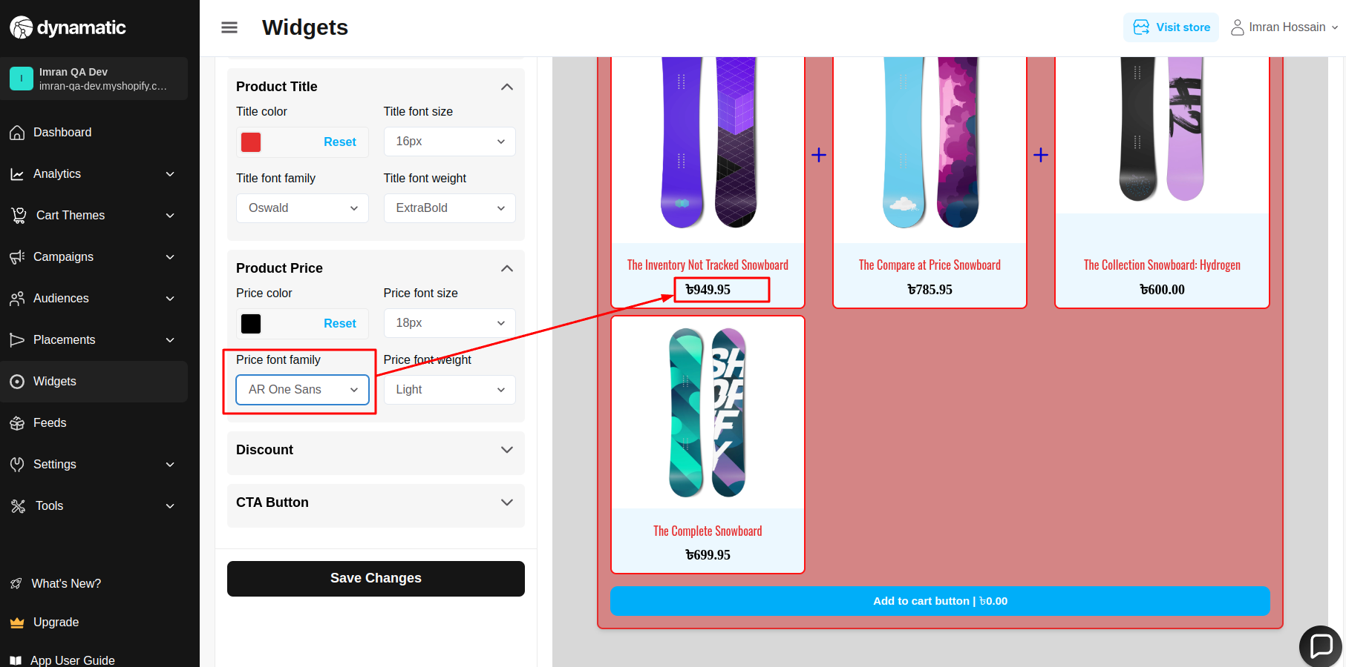

12.Product Price font weight only working with bold font weight, but other fonts are not working.

**Priority-** High

**Severity**- Medium

Status- Open

Assigned By- Imran

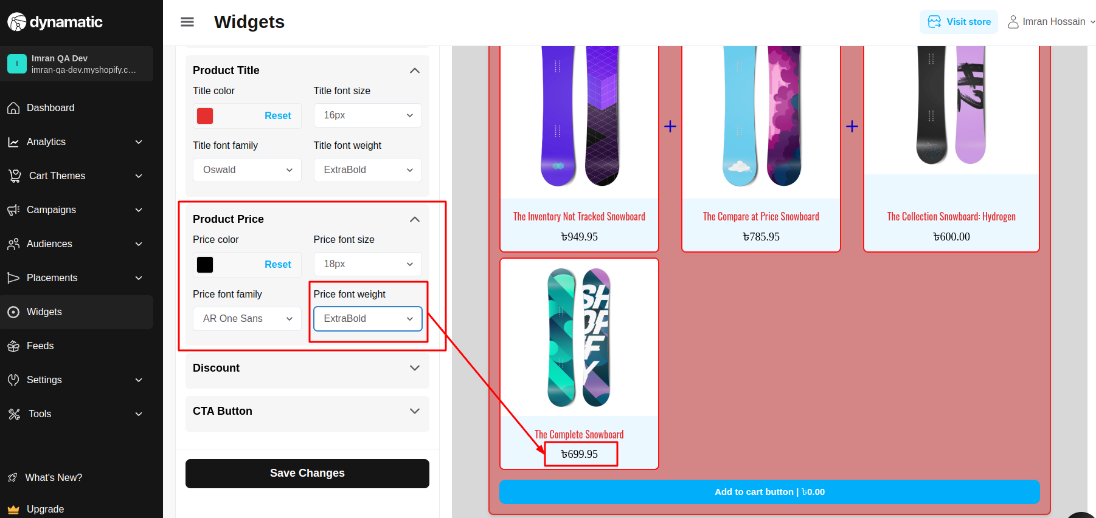

13. Discount font family (AR One Sans,ADLaM Display,AbeeZee,Abril Fatface,Aboreto,Calm) is not properly working.

**Priority-** High

**Severity**- Medium

Status- Open

Assigned By- Imran

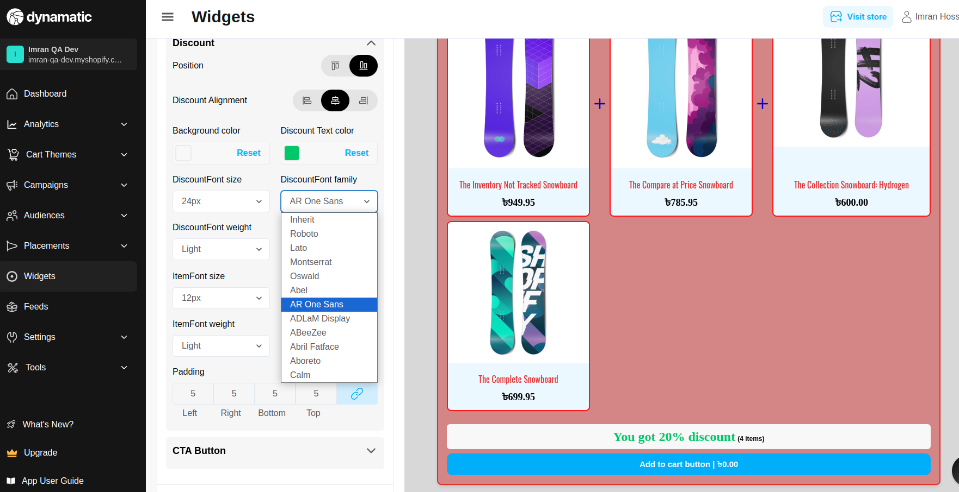

14.Discount font weight only working with bold font weight, but other fonts are not working.

**Priority-** High

**Severity**- Medium

Status- Open

Assigned By- Imran

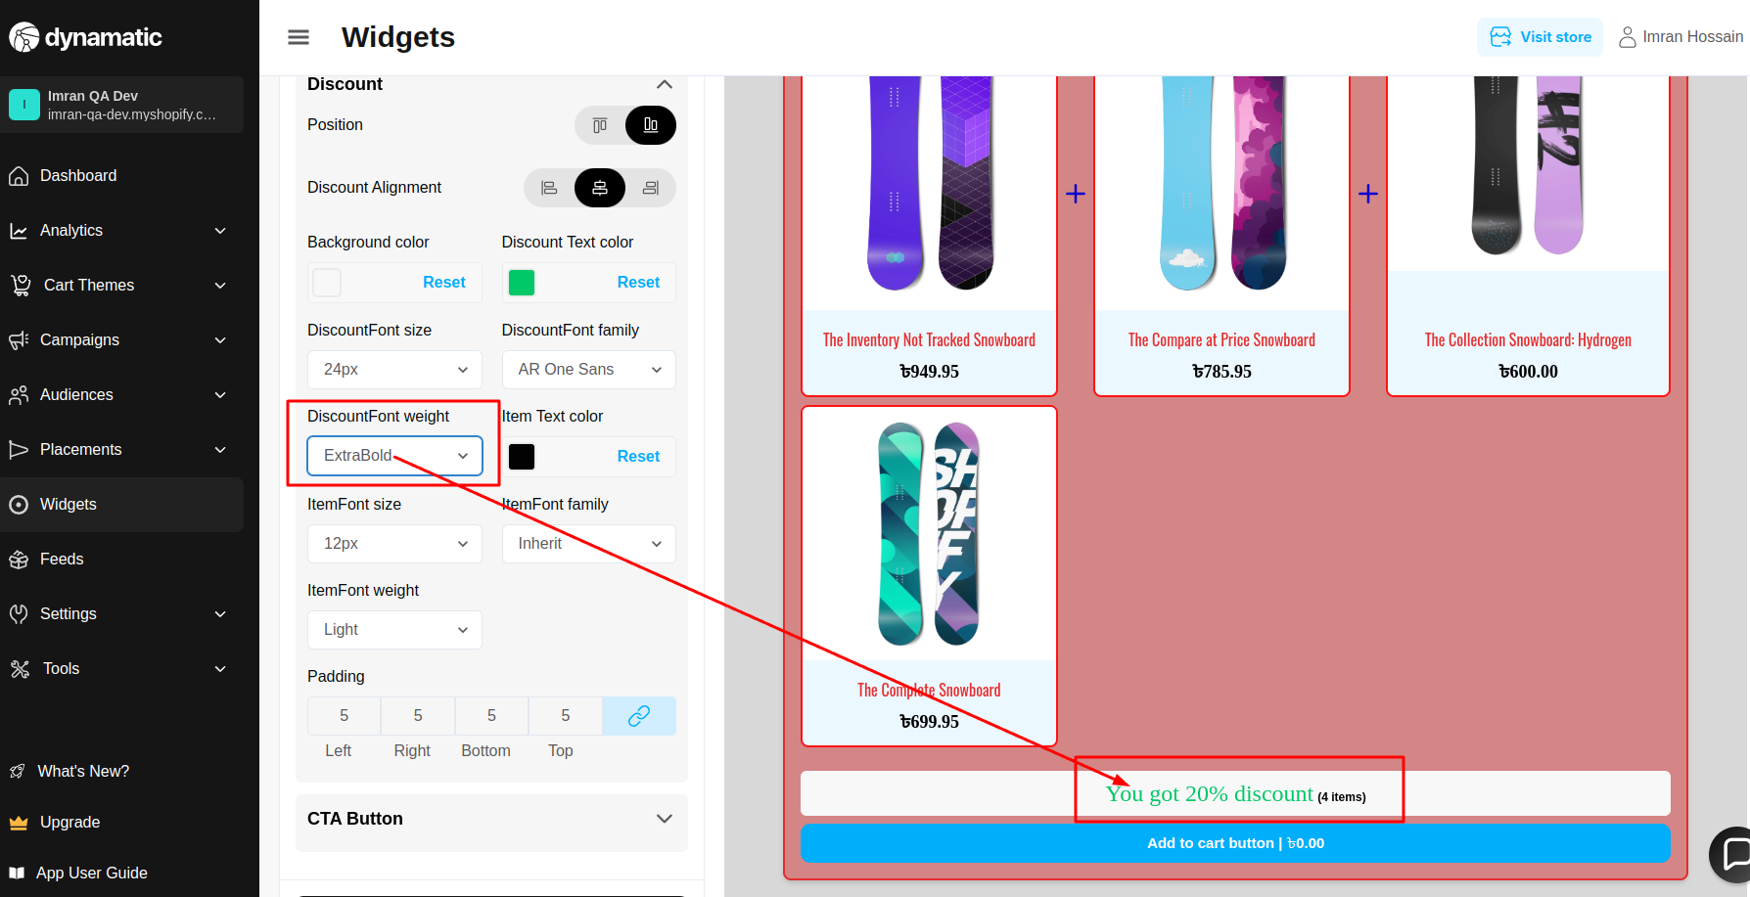

15. Discount Item font weight only working with bold font weight, but other fonts are not working.

**Priority-** High

**Severity**- Medium

Status- Open

Assigned By- Imran

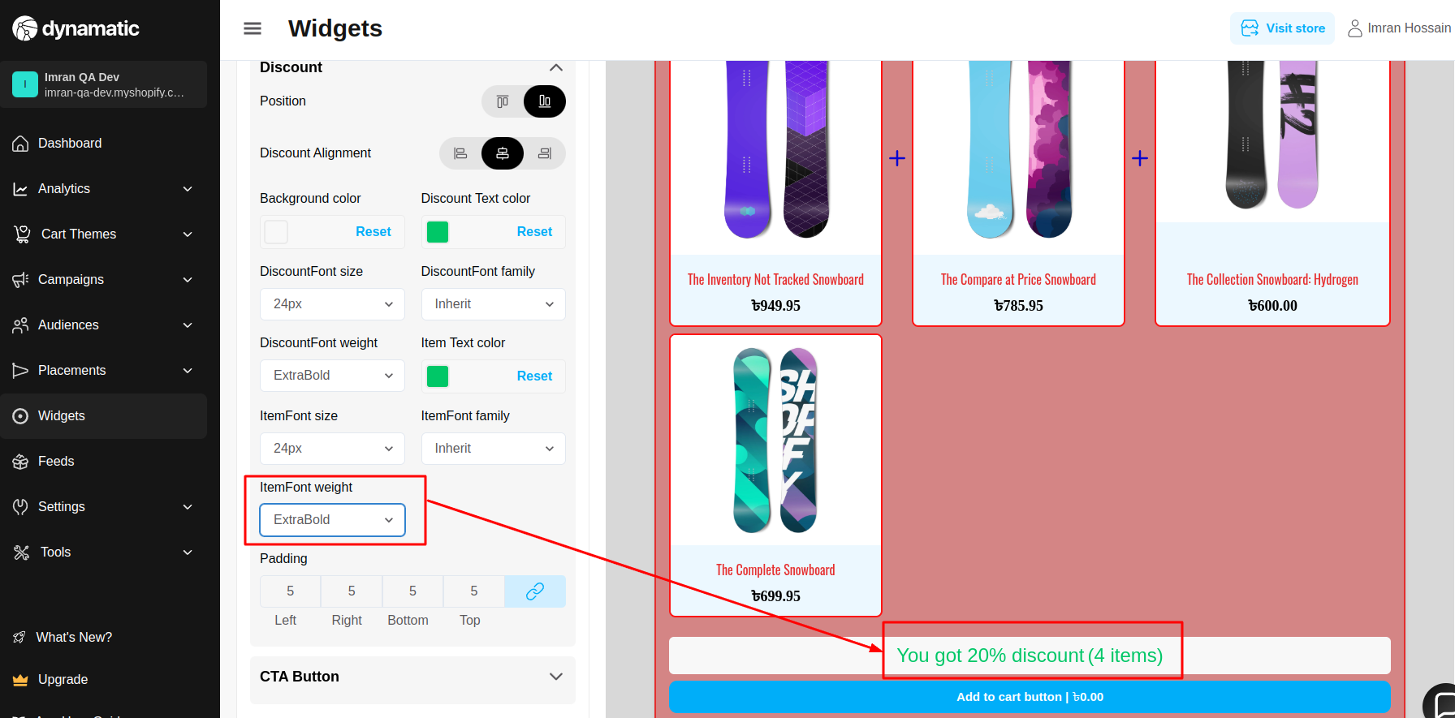

16. Negative value is added; add validation on padding.

**Priority-** High

**Severity**- Medium

Status- Open

Assigned By- Imran

